**JAVA AWT BASED – UBER EATS DATABASE-SQL CONNECTIVITY USING JDBC**

*A*

*Report*

*Submitted in partial fulfilment of the*

*Requirements for the award of the Degree of*

**BACHELOR OF ENGINEERING**

IN

**INFORMATION TECHNOLOGY**

By

**Gollapalli Sai Madhu Samhita <1602-18-737-095>**



**Department of Information Technology**

**Vasavi College of Engineering (Autonomous)**

**(Affiliated to Osmania University)**

**Ibrahimbagh, Hyderabad-31**

**2020**

**BONAFIDE CERTIFICATE**

Certified that this project report titled ”Uber Eats Database System” is a bonafide work of Miss Gollapalli Sai Madhu Samhita, who carried out the mini project work under my supervision.

Certified further that, to the best of my knowledge the work reported herein does not form part of any other project report or dissertation on the basis of which a degree or award was conferred on an earlier occasion or any other candidate.

**ABSTRACT**

Different varieties of food have a growing demand these days.  People want to enjoy different cuisines all over the world. But with increase of restaurants day-by-day dining out or takeaway is a difficult choice. An online food ordering system like “Uber Eats” shows an easy way out by bringing food to your doorstep. Customers can order food from any place and at any time provided network connection is available. “Uber Eats” provides customers with a variety of restaurants to order from. Various details of restaurant are given, like rating and food menu, making the choice of customer easy. Live tracking of order is provided. Apart from this, refund is provided when the correct order is not delivered or when the customer is not satisfied with the food. “Uber Eats” is the best choice for people looking for good food.

*“Good food equals good mood”*

1

**REQUIREMENT ANALYSIS**

**List of tables:**

·       *Restaurant Details*

·       *Customer Details*

·       *Reservation*

·       *Order Details*

* *Orders*

·       *Payment*

·       *Pays*

* *Order From*
* *Contains*
* *Reserve In*
* *Reserves*
* *Order By*

**List of attributes with their domain types:**

* *Customer*

1.   Customer Id – varchar (Primary key)

2.   Password - varchar

3.   Gmail account – varchar

4.   Name-char

5.   Phone number - Number

6.   Address – varchar

2

* *Uber Eats*

1.   Opening and Closing Time – Time

2.   Location – varchar

3.   Food Item – char

4.   Cost – Number

5.   Restaurant Id – varchar (Primary key)

* *Order Details*

1.   Location – varchar

2.   Price – Number

3.   Time of Delivery – Time

4.   Order Id – Number (Primary Key)

* *Payment*

1.   Date – date

2.   Time – time

3.   Type – varchar

4.   Cash – Number

5.   Transaction Id – Number (Primary Key)

* *Orders*

1.   Order Id – varchar (Foreign key)

2.   Customer Id – varchar (Foreign key)

* *Generates*

1.   Order Id – varchar (Foreign key)

2.   Transaction Id – varchar (Foreign key)

3

* *Order From*

1.   Restaurant Id – varchar (Foreign key)

2.   Customer Id – varchar (Foreign key)

* *Pays*

1. Customer Id – varchar2(Foreign key)
2. Transaction Id – varchar(Foreign key)

**SPECIFIC GOAL OF THE PROJECT:**

The main goal of this project is to provide an online based food ordering system, which ensures home delivery of food, chosen from a wide variety of restaurants. Details of different kind of restaurants are shown with their food menus. This allows the customer to choose food of their choice by sitting at home. An order of food from a specific restaurant can be placed via the Uber Eats Database. Payment can be done through different modes and order would be delivered to the required location.

SQL particular - Uber Eats, Customer, Order, Payment methods.

* **Architecture and technology used:**

**SQL Plus** is the most basic Oracle Database utility with a basic command-line interface, commonly used by users, administrators and programmers.

The interface of SQL Plus is used for creating the database. DDL and DML commands are implemented for operations being executed. The details of various Online MOOC’s provider, courses, student, assignments, and results are stored in the form of tables in the database.

**Eclipse** is an integrated development environment (IDE) used in computer programming. It contains a base workspace and an extensible plug-in system for customizing the environment. Eclipse is written mostly in java and its primary use is for developing Java applications, but it may also be used to develop applications in other programming languages via plug-ins, including Erlang, Java Scripts etc.

The front-end application code is written in “**Java**” using Eclipse. The portal for front end application is designed through Eclipse, runs and has the capacity to connect with the database which has data inserted using SQL.

|  |
| --- |
|  |
|  |

**DESIGN**

**ER DIAGRAM**

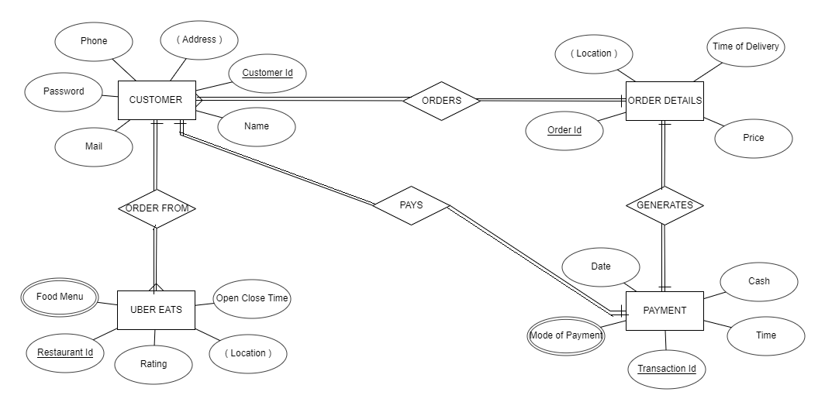

**Mapping Cardinalities and Constraints**

* Customer(many) Order from Uber Eats(one)

One Customer can place an order from one Restaurant, but One Restaurant can receive orders from many Restaurants.

* Customer(one) Orders Order Details(many)

One Customer can place many orders, but one order is places by one Customer.

* Order Details(one) Generates Payment(one)

One Order generates one bill and one bill is generated by one Order.

* Customer(one) Pays Payment(one)

One Customer can make one Payment regarding one order and one Payment is made by only one Customer regarding one order.

**DDL COMMANDS**

SQL> create table Customer(

2 Cid varchar2(20),

3 Password varchar2(16),

4 Mail varchar2(16),

5 Name char(20),

6 Address varchar2(50),

7 Phone number(12));

Table created.

SQL> create table UberEats(

2 OpenCloseTime number(10),

3 Location varchar2(50),

4 Rating number(5),

5 Rid varchar2(20),

6 FoodMenu varchar2(20));

Table created.

SQL> create table OrderDetails(

2 Location varchar2(50),

3 Price number(10),

4 Time number(10),

5 Oid number(20));

Table created.

SQL> create table Payment(

2 Dt date,

3 Tm varchar2(7),

4 Type varchar2(20),

5 Cash number(6),

6 Tid number(20));

Table created.

SQL> create table OrderFroms(

2 Cid varchar2(20),

3 Rid varchar2(20));

Table created.

SQL> create table Orders(

2 Oid number(10),

3 Cid varchar2(20));

Table created.

SQL> create table Pays(

2 Cid varchar2(20),

3 Tid number(20));

Table created.

SQL> create table Generates(

2 Oid number(20),

3 Tid number(20));

Table created.

SQL> alter table Customer add primary key(Cid);

Table altered.

SQL> alter table UberEats add primary key(Rid);

Table altered.

SQL> alter table Payment add primary key(Tid);

Table altered.

SQL> alter table OrderDetails add primary key(Oid);

Table altered.

SQL> alter table Pays add foreign key(Cid) references Customer;

Table altered.

SQL> alter table Pays add foreign key(Tid) references Payment;

Table altered.

SQL> alter table OrderFrom add foreign key(Cid) references Customer;

Table altered.

SQL> alter table OrderFrom add foreign key(Rid) references UberEats;

Table altered.

SQL> alter table Orders add foreign key(Cid) references Customer;

Table altered.

SQL> alter table Orders add foreign key(Oid) references OrderDetails;

Table altered.

SQL> alter table Generates add foreign key(Oid) references OrderDetails;

Table altered.

SQL> alter table Generates add foreign key(Tid) references Payment;

Table altered.

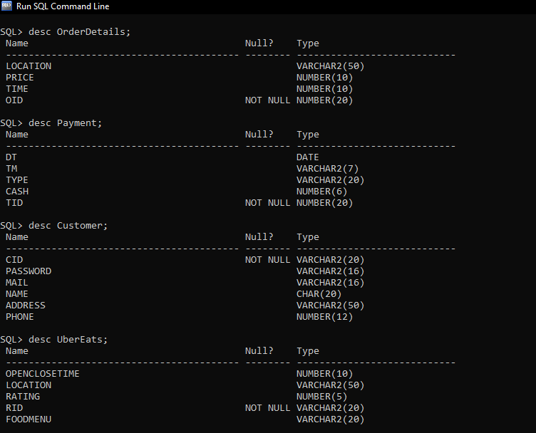

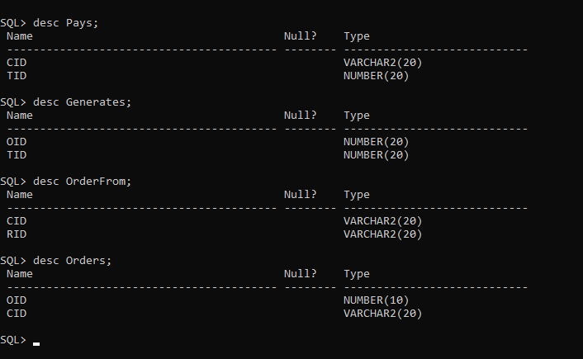

**DML COMMANDS**

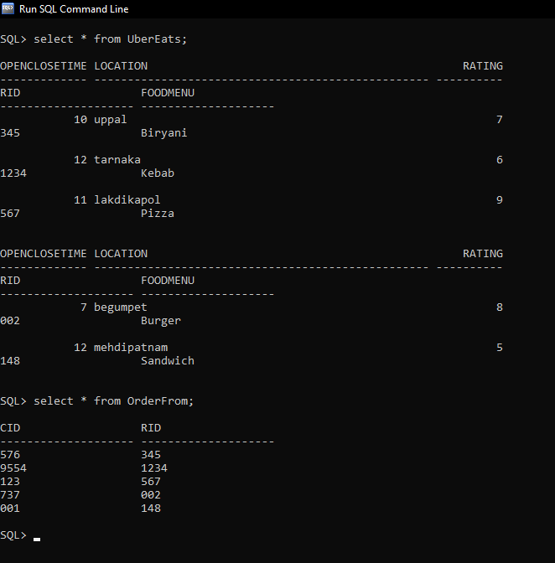

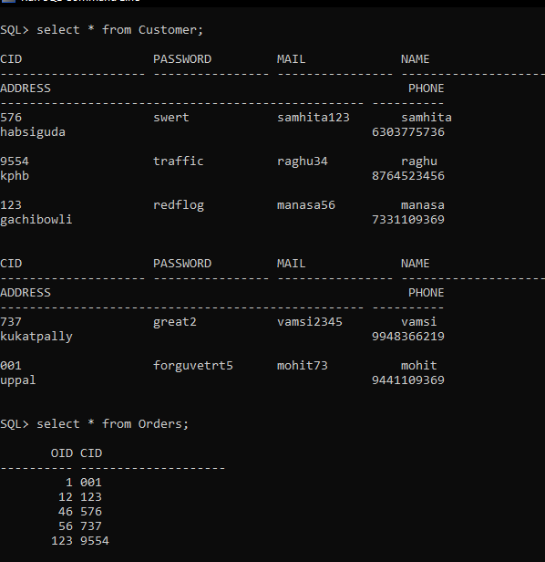

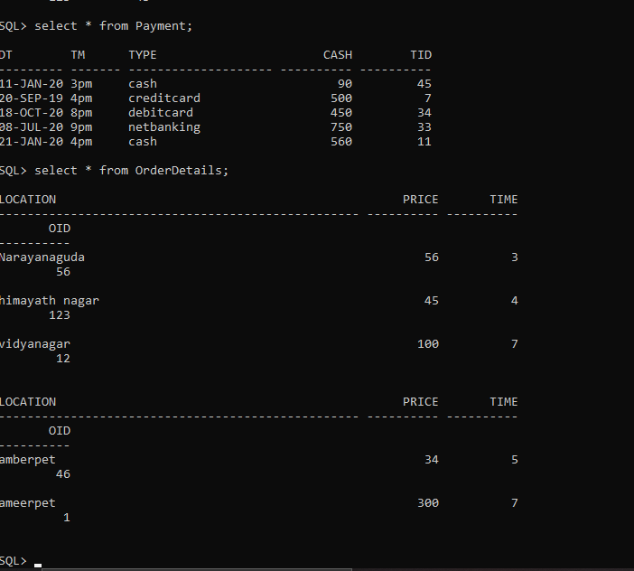

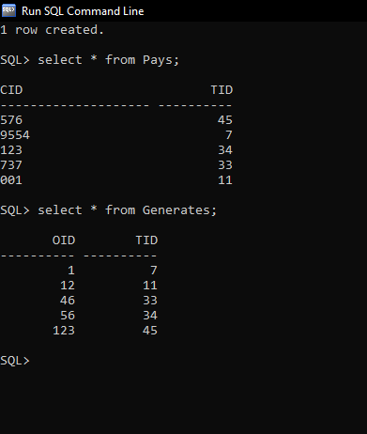

IMPLEMENTATION

Front End Programs:

1. Insert Customer-

import java.awt.*;

import java.awt.event.*;

import java.sql.*;

public class InsertCustomer extends Panel

{

Button insertCustomerButton;

TextField cidText, cnameText, addressText, mailText,passwordText,phoneText;

TextArea errorText;

Connection connection;

Statement statement;

public InsertCustomer()

{

try

{

Class.forName("oracle.jdbc.driver.OracleDriver");

}

catch (Exception e)

{

System.err.println("Unable to find and load driver");

System.exit(1);

}

connectToDB();

}

public void connectToDB()

{

try

{

connection = DriverManager.getConnection("jdbc:oracle:thin:@localhost:1521:xe","system","OracleDBMS2090&");

statement = connection.createStatement();

}

catch (SQLException connectException)

{

System.out.println(connectException.getMessage());

System.out.println(connectException.getSQLState());

System.out.println(connectException.getErrorCode());

System.exit(1);

}

}

public void buildGUI()

{

insertCustomerButton = new Button("Submit");

insertCustomerButton.addActionListener(new ActionListener()

{

public void actionPerformed(ActionEvent e)

{

try

{

Statement statement = connection.createStatement();

String query= "INSERT INTO Customer VALUES('" + cidText.getText() + "', " + "'" + passwordText.getText() + "'," + "'" + mailText.getText() + "',"+"'"+cnameText.getText()+"'," +"'"+addressText.getText()+"',"+phoneText.getText()+")";

int i = statement.executeUpdate(query);

errorText.append("\nInserted " + i + " rows successfully");

}

catch (SQLException insertException)

{

displaySQLErrors(insertException);

}

}

});

cnameText = new TextField(15);

cidText = new TextField(15);

addressText = new TextField(15);

mailText = new TextField(15);

passwordText = new TextField(15);

phoneText = new TextField(15);

errorText = new TextArea(10,40);

errorText.setEditable(false);

Panel first = new Panel();

first.setLayout(new GridLayout(6,2));

first.add(new Label("Customer ID:"));

first.add(cidText);

first.add(new Label("Name:"));

first.add(cnameText);

first.add(new Label("Address:"));

first.add(addressText);

first.add(new Label("Mail"));

first.add(mailText);

first.add(new Label("Password:"));

first.add(passwordText);

first.add(new Label("Phone:"));

first.add(phoneText);

first.setBounds(125,90,300,150);

Panel second = new Panel(new GridLayout(4, 1));

second.add(insertCustomerButton);

second.setBounds(195,290,150,100);

Panel third = new Panel();

third.add(errorText);

third.setBounds(80,410,430,300);

setLayout(null);

add(first);

add(second);

add(third);

setSize(500,600);

setVisible(true);

}

private void displaySQLErrors(SQLException e)

{

errorText.append("\nSQLException: " + e.getMessage() + "\n");

errorText.append("SQLState: " + e.getSQLState() + "\n");

errorText.append("VendorError: " + e.getErrorCode() + "\n");

}

public static void main(String[] args)

{

InsertCustomer incus = new InsertCustomer();

incus.buildGUI();

}

}

2)Delete Customer-

import java.awt.*;

import java.awt.event.*;

import java.sql.*;

public class DeleteCustomer extends Panel

{

Button deleteCustomerButton;

List CustomerIDList;

TextField cidText, cnameText, mailText, passwordText,addressText,phoneText;

TextArea errorText;

Connection connection;

Statement statement;

ResultSet rs;

public DeleteCustomer()

{

try

{

Class.forName("oracle.jdbc.driver.OracleDriver");

}

catch (Exception e)

{

System.err.println("Unable to find and load driver");

System.exit(1);

}

connectToDB();

}

public void connectToDB()

{

try

{

connection = DriverManager.getConnection("jdbc:oracle:thin:@localhost:1521:xe","system","OracleDBMS2090&");

statement = connection.createStatement();

}

catch (SQLException connectException)

{

System.out.println(connectException.getMessage());

System.out.println(connectException.getSQLState());

System.out.println(connectException.getErrorCode());

System.exit(1);

}

}

private void loadCustomer()

{

try

{

rs = statement.executeQuery("SELECT * FROM Customer");

while (rs.next())

{

CustomerIDList.add(rs.getString("CID"));

}

}

catch (SQLException e)

{

displaySQLErrors(e);

}

}

public void buildGUI()

{

CustomerIDList = new List(10);

loadCustomer();

add(CustomerIDList);

//When a list item is selected populate the text fields

CustomerIDList.addItemListener(new ItemListener()

{

public void itemStateChanged(ItemEvent e)

{

try

{

rs = statement.executeQuery("SELECT * FROM Customer");

while (rs.next())

{

if (rs.getString("CID").equals(CustomerIDList.getSelectedItem()))

break;

}

if (!rs.isAfterLast())

{

cidText.setText(rs.getString("CID"));

passwordText.setText(rs.getString("Password"));

mailText.setText(rs.getString("Mail"));

cnameText.setText(rs.getString("Name"));

addressText.setText(rs.getString("Address"));

phoneText.setText(rs.getString("Phone"));

}

}

catch (SQLException selectException)

{

displaySQLErrors(selectException);

}

}

});

deleteCustomerButton = new Button("Delete");

deleteCustomerButton.addActionListener(new ActionListener()

{

public void actionPerformed(ActionEvent e)

{

try

{

Statement statement = connection.createStatement();

int i = statement.executeUpdate("DELETE FROM Customer WHERE CID = '"

+ CustomerIDList.getSelectedItem()+"'");

errorText.append("\nDeleted " + i + " rows successfully");

cidText.setText(null);

passwordText.setText(null);

mailText.setText(null);

cnameText.setText(null);

addressText.setText(null);

phoneText.setText(null);

CustomerIDList.removeAll();

loadCustomer();

}

catch (SQLException insertException)

{

displaySQLErrors(insertException);

}

}

});

cidText = new TextField(15);

cnameText = new TextField(15);

mailText = new TextField(15);

passwordText = new TextField(15);

addressText= new TextField(15);

phoneText= new TextField(15);

errorText = new TextArea(10, 40);

errorText.setEditable(false);

Panel first = new Panel();

first.setLayout(new GridLayout(6, 1));

first.add(new Label("Customer ID:"));

first.add(cidText);

cidText.setEditable(false);

first.add(new Label("Name:"));

first.add(cnameText);

cnameText.setEditable(false);

first.add(new Label("Mail:"));

first.add(mailText);

mailText.setEditable(false);

first.add(new Label("Password:"));

first.add(passwordText);

passwordText.setEditable(false);

first.add(new Label("Address:"));

first.add(addressText);

addressText.setEditable(false);

first.add(new Label("Phones:"));

first.add(phoneText);

phoneText.setEditable(false);

Panel second = new Panel(new GridLayout(4, 1));

second.add(deleteCustomerButton);

Panel third = new Panel();

third.add(errorText);

add(first);

add(second);

add(third);

setSize(450, 600);

setLayout(new FlowLayout());

setVisible(true);

}

private void displaySQLErrors(SQLException e)

{

errorText.append("\nSQLException: " + e.getMessage() + "\n");

errorText.append("SQLState: " + e.getSQLState() + "\n");

errorText.append("VendorError: " + e.getErrorCode() + "\n");

}

public static void main(String[] args)

{

DeleteCustomer delcus = new DeleteCustomer();

delcus.buildGUI();

}

}

3)Update Customer-

import java.awt.*;

import java.awt.event.*;

import java.sql.*;

public class UpdateCustomer extends Panel

{

Button updateCustomerButton;

List CustomerIDList;

TextField cidText,cnameText, mailText, passwordText,addressText,phoneText;

TextArea errorText;

Connection connection;

Statement statement;

ResultSet rs;

public UpdateCustomer()

{

try

{

Class.forName("oracle.jdbc.driver.OracleDriver");

}

catch (Exception e)

{

System.err.println("Unable to find and load driver");

System.exit(1);

}

connectToDB();

}

public void connectToDB()

{

try

{

connection = DriverManager.getConnection("jdbc:oracle:thin:@localhost:1521:xe","system","OracleDBMS2090&");

statement = connection.createStatement();

}

catch (SQLException connectException)

{

System.out.println(connectException.getMessage());

System.out.println(connectException.getSQLState());

System.out.println(connectException.getErrorCode());

System.exit(1);

}

}

private void loadCustomer()

{

try

{

rs = statement.executeQuery("SELECT CID FROM Customer");

while (rs.next())

{

CustomerIDList.add(rs.getString("CID"));

}

}

catch (SQLException e)

{

displaySQLErrors(e);

}

}

public void buildGUI()

{

CustomerIDList = new List(10);

loadCustomer();

add(CustomerIDList);

//When a list item is selected populate the text fields

CustomerIDList.addItemListener(new ItemListener()

{

public void itemStateChanged(ItemEvent e)

{

try

{

rs = statement.executeQuery("SELECT * FROM Customer");

while (rs.next())

{

if (rs.getString("CID").equals(CustomerIDList.getSelectedItem()))

break;

}

if (!rs.isAfterLast())

{

cidText.setText(rs.getString("CID"));

passwordText.setText(rs.getString("Password"));

mailText.setText(rs.getString("Mail"));

cnameText.setText(rs.getString("Name"));

addressText.setText(rs.getString("Address"));

phoneText.setText(rs.getString("Phone"));

}

}

catch (SQLException selectException)

{

displaySQLErrors(selectException);

}

}

});

updateCustomerButton = new Button("Modify");

updateCustomerButton.addActionListener(new ActionListener()

{

public void actionPerformed(ActionEvent e)

{

try

{

Statement statement = connection.createStatement();

int i = statement.executeUpdate("UPDATE Customer "

+ "SET password='" + passwordText.getText() + "', "

+ "mail='" + mailText.getText() + "', "

+ "name ='"+ cnameText.getText()+"',"

+"address ='"+ addressText.getText()+"',"

+"phone=" +phoneText.getText()+ " WHERE Cid = '"

+ CustomerIDList.getSelectedItem()+"'");

errorText.append("\nUpdated " + i + " rows successfully");

CustomerIDList.removeAll();

loadCustomer();

}

catch (SQLException insertException)

{

displaySQLErrors(insertException);

}

}

});

cidText = new TextField(15);

cidText.setEditable(false);

cnameText = new TextField(15);

mailText = new TextField(15);

passwordText = new TextField(15);

addressText=new TextField(15);

phoneText=new TextField(15);

errorText = new TextArea(10, 40);

errorText.setEditable(false);

Panel first = new Panel();

first.setLayout(new GridLayout(6, 2));

first.add(new Label("Customer ID:"));

first.add(cidText);

first.add(new Label("Name:"));

first.add(cnameText);

first.add(new Label("Mail:"));

first.add(mailText);

first.add(new Label("Password:"));

first.add(passwordText);

first.add(new Label("Address:"));

first.add(addressText);

first.add(new Label("Phone:"));

first.add(phoneText);

Panel second = new Panel(new GridLayout(4, 1));

second.add(updateCustomerButton);

Panel third = new Panel();

third.add(errorText);

add(first);

add(second);

add(third);

setSize(500, 600);

setLayout(new FlowLayout());

setVisible(true);

}

private void displaySQLErrors(SQLException e)

{

errorText.append("\nSQLException: " + e.getMessage() + "\n");

errorText.append("SQLState: " + e.getSQLState() + "\n");

errorText.append("VendorError: " + e.getErrorCode() + "\n");

}

public static void main(String[] args)

{

UpdateCustomer upc = new UpdateCustomer();

upc.buildGUI();

}

}

4)Main Method-

import java.awt.*;

import java.awt.event.*;

class UberEatsDatabase extends Frame implements ActionListener

{

String msg = "";

Label ll,l2;

CardLayout cardLO;

InsertCustomer incus;

UpdateCustomer upcus;

DeleteCustomer delcus;

InsertRestaurant inres;

UpdateRestaurant upres;

DeleteRestaurant delres;

InsertOrder ino;

DeleteOrder delo;

UpdateOrder upo;

InsertPayment inpay;

UpdatePayment uppay;

DeletePayment delpay;

InsertOrders inords;

UpdateOrders upords;

DeleteOrders delords;

InsertOrderFrom inorf;

UpdateOrderFrom uporf;

DeleteOrderFrom delorf;

InsertPays inpays;

UpdatePays uppays;

DeletePays delpays;

InsertGenerates ingen;

UpdateGenerates upgen;

DeleteGenerates delgen;

Panel home,welcome;

UberEatsDatabase()

{

cardLO = new CardLayout();

home = new Panel();

home.setLayout(cardLO);

ll = new Label();

l2 =new Label();

ll.setAlignment(Label.CENTER);

l2.setAlignment(Label.CENTER);

ll.setText("Welcome to UBER EATS");

l2.setText("\nAll @rights are reserved");

//Create welcome panel and add the label to it

welcome = new Panel();

welcome.add(ll);

welcome.add(l2);

//create panels for each of our menu items and build them with respective components

incus = new InsertCustomer(); incus.buildGUI();

upcus = new UpdateCustomer(); upcus.buildGUI();

delcus = new DeleteCustomer(); delcus.buildGUI();

inres = new InsertRestaurant();inres.buildGUI();

upres= new UpdateRestaurant();upres.buildGUI();

delres = new DeleteRestaurant();delres.buildGUI();

ino = new InsertOrder();ino.buildGUI();

delo = new DeleteOrder();delo.buildGUI();

upo= new UpdateOrder();upo.buildGUI();

inpay= new InsertPayment(); inpay.buildGUI();

uppay= new UpdatePayment();uppay.buildGUI();

delpay = new DeletePayment(); delpay.buildGUI();

inords = new InsertOrders();inords.buildGUI();

upords = new UpdateOrders();upords.buildGUI();

delords = new DeleteOrders();delords.buildGUI();

inorf = new InsertOrderFrom();inorf.buildGUI();

delorf = new DeleteOrderFrom();delorf.buildGUI();

uporf = new UpdateOrderFrom();uporf.buildGUI();

inpays = new InsertPays();inpays.buildGUI();

delpays = new DeletePays();delpays.buildGUI();

uppays = new UpdatePays();uppays.buildGUI();

ingen = new InsertGenerates();ingen.buildGUI();

delgen = new DeleteGenerates();delgen.buildGUI();

upgen = new UpdateGenerates();upgen.buildGUI();

//add all the panels to the home panel which has a cardlayout

home.add(welcome, "Welcome");

home.add(incus, "InsertCustomer");

home.add(upcus, "UpdateCustomer");

home.add(delcus, "DeleteCustomer");

home.add(inres,"InsertRestaurant");

home.add(upres,"UpdateRestaurant");

home.add(delres,"DeleteRestaurant");

home.add(ino,"InsertOrder");

home.add(delo,"DeleteOrder");

home.add(upo,"UpdateOrder");

home.add(inpay,"InsertPayment");

home.add(uppay,"UpdatePayment");

home.add(delpay,"DeletePayment");

home.add(inords,"InsertOrders");

home.add(upords,"UpdateOrders");

home.add(delords,"DeleteOrders");

home.add(inpays,"InsertPays");

home.add(delpays,"DeletePays");

home.add(uppays,"UpdatePays");

home.add(inorf,"InsertOrderFrom");

home.add(delorf,"DeleteOrderFrom");

home.add(uporf,"UpdateOrderFrom");

home.add(ingen,"InsertGenerates");

home.add(delgen,"DeleteGenerates");

home.add(upgen,"UpdateGenerates");

// add home panel to main frame

add(home);

// create menu bar and add it to frame

MenuBar mbar = new MenuBar();

setMenuBar(mbar);

// create the menu items and add it to Menu

Menu customer= new Menu("Customer Details");

MenuItem item1, item2, item3;

customer.add(item1 = new MenuItem("Insert Customer"));

customer.add(item2 = new MenuItem("View Customer"));

customer.add(item3 = new MenuItem("Delete Customer"));

mbar.add(customer);

Menu res = new Menu("UberEats");

MenuItem item4, item5, item6;

res.add(item4 = new MenuItem("Insert Restaurant"));

res.add(item5 = new MenuItem("View Restaurant"));

res.add(item6 = new MenuItem("Delete Restaurant"));

mbar.add(res);

Menu order = new Menu("Order Details");

MenuItem item7, item8, item9;

order.add(item7 = new MenuItem("Insert Order"));

order.add(item8 = new MenuItem("View Order"));

order.add(item9 = new MenuItem("Delete Order"));

mbar.add(order);

Menu payment= new Menu("Payment Details");

MenuItem item10, item11, item12;

payment.add(item10 = new MenuItem("Insert Payment"));

payment.add(item11= new MenuItem("View Payment"));

payment.add(item12 = new MenuItem("Delete Payment"));

mbar.add(payment);

Menu orders= new Menu("Orders");

MenuItem item13, item14, item15;

orders.add(item13 = new MenuItem("Insert Orders"));

orders.add(item14= new MenuItem("View Orders"));

orders.add(item15 = new MenuItem("Delete Orders"));

mbar.add(orders);

Menu orderFrom= new Menu("Order From");

MenuItem item16, item17, item18;

orderFrom.add(item16 = new MenuItem("Insert Order From"));

orderFrom.add(item17= new MenuItem("View Order From"));

orderFrom.add(item18 = new MenuItem("Delete Order From"));

mbar.add(orderFrom);

Menu pays= new Menu("Pays");

MenuItem item19, item20, item21;

pays.add(item19 = new MenuItem("Insert Pays"));

pays.add(item20= new MenuItem("View Pays"));

pays.add(item21 = new MenuItem("Delete Pays"));

mbar.add(pays);

Menu generates= new Menu("Generates");

MenuItem item22, item23, item24;

generates.add(item22 = new MenuItem("Insert Generates"));

generates.add(item23= new MenuItem("View Generates"));

generates.add(item24 = new MenuItem("Delete Generates"));

mbar.add(generates);

// register listeners

item1.addActionListener(this);

item2.addActionListener(this);

item3.addActionListener(this);

item4.addActionListener(this);

item5.addActionListener(this);

item6.addActionListener(this);

item7.addActionListener(this);

item8.addActionListener(this);

item9.addActionListener(this);

item10.addActionListener(this);

item11.addActionListener(this);

item12.addActionListener(this);

item13.addActionListener(this);

item14.addActionListener(this);

item15.addActionListener(this);

item16.addActionListener(this);

item17.addActionListener(this);

item18.addActionListener(this);

item19.addActionListener(this);

item20.addActionListener(this);

item21.addActionListener(this);

item22.addActionListener(this);

item23.addActionListener(this);

item24.addActionListener(this);

// Anonymous inner class which extends WindowAdaptor to handle the Window event: windowClosing

addWindowListener(new WindowAdapter(){

public void windowClosing(WindowEvent we)

{

System.exit(0);

}

});

//Frame properties

setTitle("UBER EATS");

Color clr = new Color(255, 102, 102);

setBackground(clr);

setFont(new Font("Monaco", Font.BOLD, 20));

setSize(900, 1000);

setVisible(true);

}

public void actionPerformed(ActionEvent ae)

{

String arg = ae.getActionCommand();

if(arg.equals("Insert Customer"))

{

cardLO.show(home, "InsertCustomer");

}

else if(arg.equals("View Customer"))

{

cardLO.show(home, "UpdateCustomer");

}

else if(arg.equals("Delete Customer"))

{

cardLO.show(home, "DeleteCustomer");

}

else if(arg.equals("Insert Restaurant"))

{

cardLO.show(home, "InsertRestaurant");

}

else if(arg.equals("Delete Restaurant"))

{

cardLO.show(home, "DeleteRestaurant");

}

else if(arg.equals("View Restaurant"))

{

cardLO.show(home, "UpdateRestaurant");

}

else if(arg.equals("Insert Order"))

{

cardLO.show(home, "InsertOrder");

}

else if(arg.equals("Delete Order"))

{

cardLO.show(home, "DeleteOrder");

}

else if(arg.equals("View Order"))

{

cardLO.show(home, "UpdateOrder");

}

else if(arg.equals("Insert Payment"))

{

cardLO.show(home, "InsertPayment");

}

else if(arg.equals("View Payment"))

{

cardLO.show(home, "UpdatePayment");

}

else if(arg.equals("Delete Payment"))

{

cardLO.show(home, "DeletePayment");

}

else if(arg.equals("Insert Orders"))

{

cardLO.show(home, "InsertOrders");

}

else if(arg.equals("View Orders"))

{

cardLO.show(home, "UpdateOrders");

}

else if(arg.equals("Delete Orders"))

{

cardLO.show(home, "DeleteOrders");

}

else if(arg.equals("Insert Order From"))

{

cardLO.show(home, "InsertOrderFrom");

}

else if(arg.equals("View Order From"))

{

cardLO.show(home, "UpdateOrderFrom");

}

else if(arg.equals("Delete Order From"))

{

cardLO.show(home, "DeleteOrderFrom");

}

else if(arg.equals("Insert Pays"))

{

cardLO.show(home, "InsertPays");

}

else if(arg.equals("View Pays"))

{

cardLO.show(home, "UpdatePays");

}

else if(arg.equals("Delete Pays"))

{

cardLO.show(home, "DeletePays");

}

else if(arg.equals("Insert Generates"))

{

cardLO.show(home, "InsertGenerates");

}

else if(arg.equals("View Generates"))

{

cardLO.show(home, "UpdateGenerates");

}

else if(arg.equals("Delete Generates"))

{

cardLO.show(home, "DeleteGenerates");

}

}

public static void main(String ... args)

{

new UberEatsDatabase();

}

}

Connectivity with the Database:

Java Database Connectivity (JDBC) is an application programming interface (API) for the programming language Java, which defines how a client may access a database. It is a Java-based data access technology used for Java database connectivity. It is a part of the Java Standard Edition platform, from Oracle Corporation. It provides methods to query and update data in a database and is oriented towards relational databases.

Block of Code for JAVA-SQL connectivity with JDBC:

public void connectToDB()

{

try

{

connection = DriverManager.getConnection("jdbc:oracle:thin:@localhost:1521:xe","system","OracleDBMS2090&");

statement = connection.createStatement();

}

catch (SQLException connectException)

{

System.out.println(connectException.getMessage());

System.out.println(connectException.getSQLState());

System.out.println(connectException.getErrorCode());

System.exit(1);

}

}

GITHUB LINK:

<https://github.com/Samhita20/DBMS-ASSIGNMENT>

Folder Structure:

This project consists of a folder named src which has 25 .java files. The files are for 8 different tables, including four relation tables. The programs include insert, update, delete functionalities and the main function. By which we can navigate easily to reach the java code and we can make changes easily.

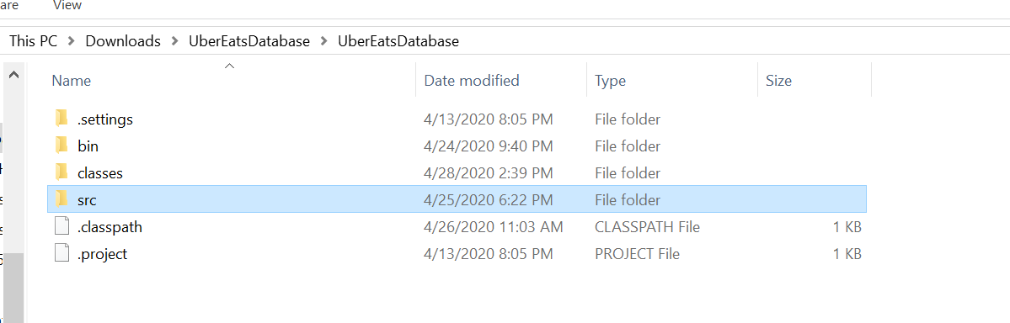

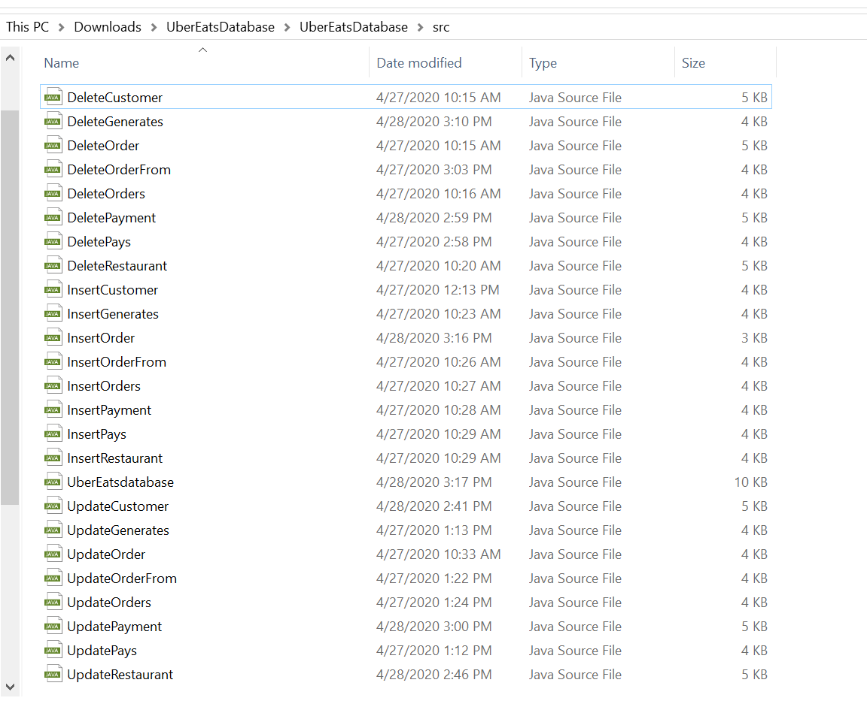

TESTING

The program runts for the three basic operations of insertion, updating, and deletion on 8 different tables. Along with this, it also has a output column which gives the information about how many rows have been edited, Errors, syntactical or exceptional will be shown if occurred.

The code written for building GUI and connecting with database ensures that the values entered by the users are of correct data types. It prompts an error message in the text message box.

Home Page:

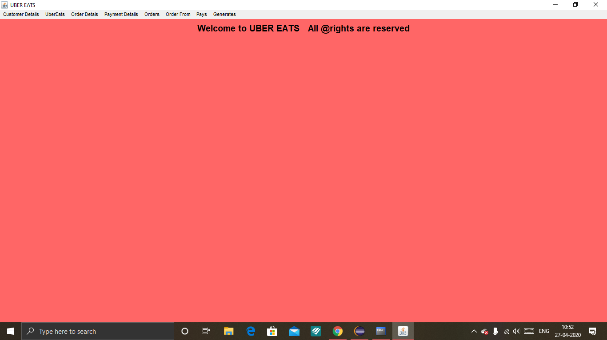

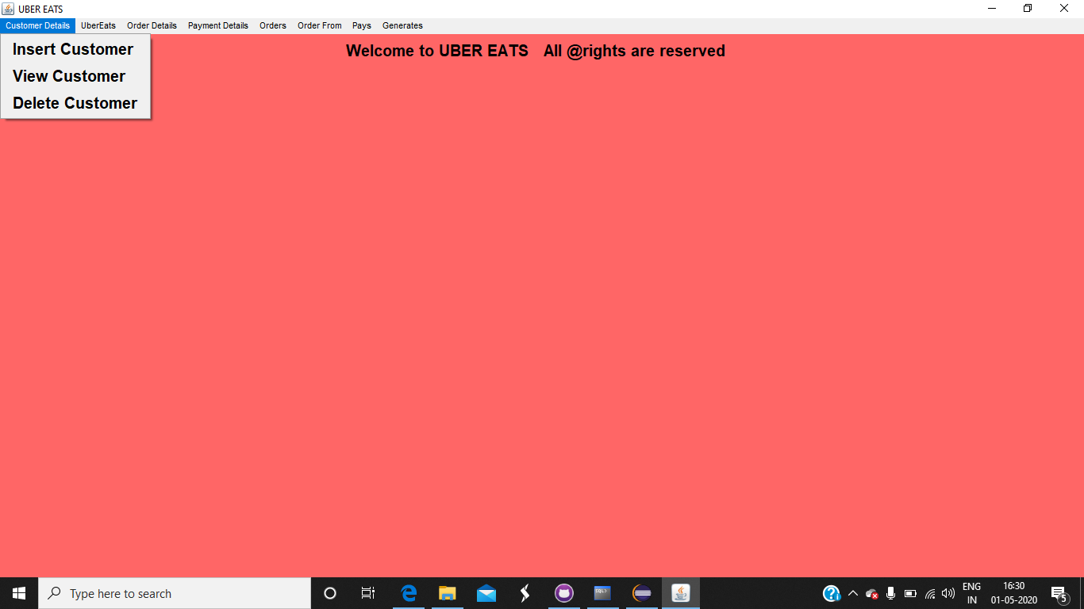

Insertion:

Error-

If user given invalid content it gives an error.

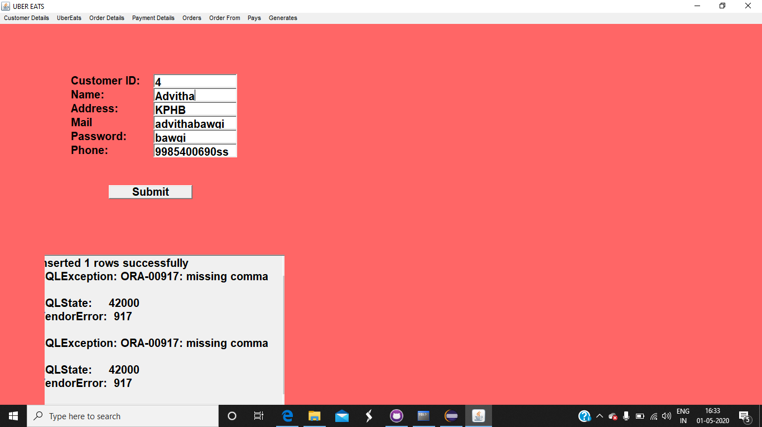

Proper Entry-

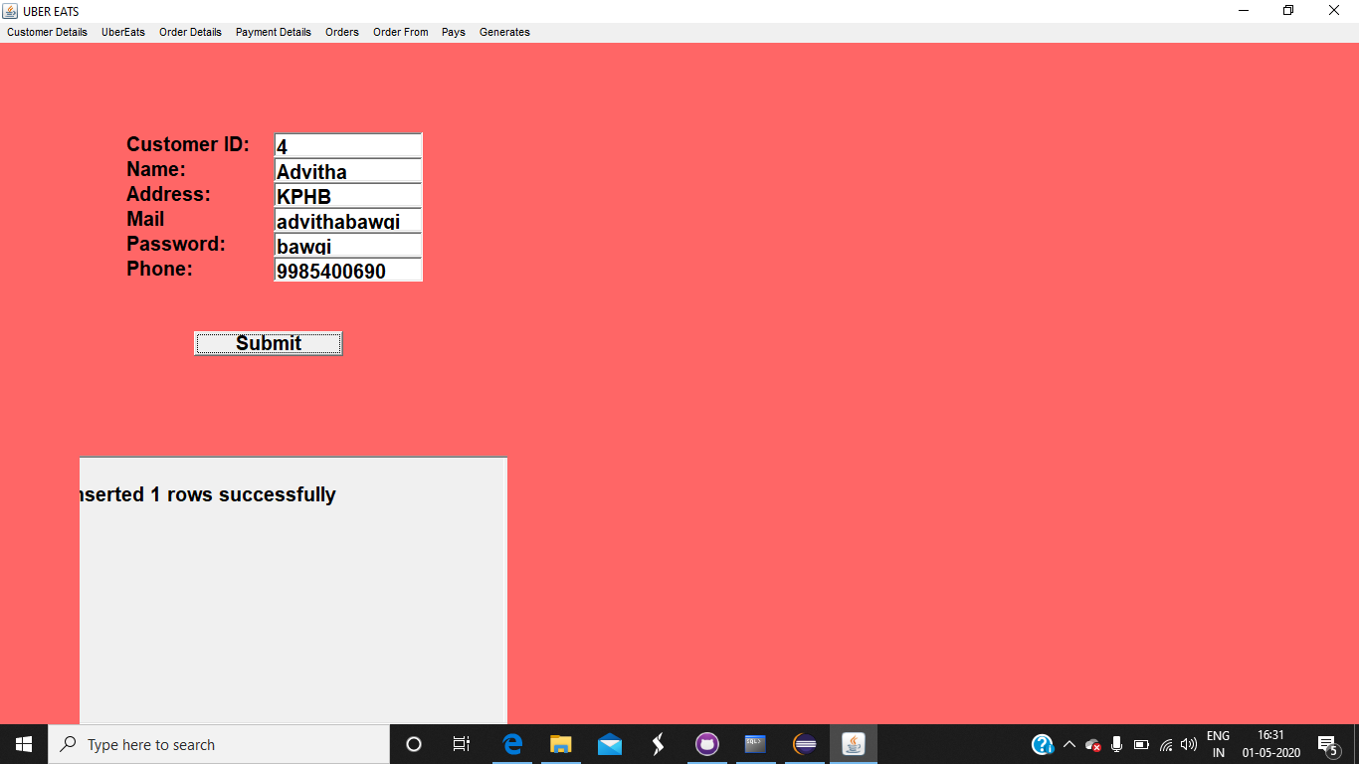

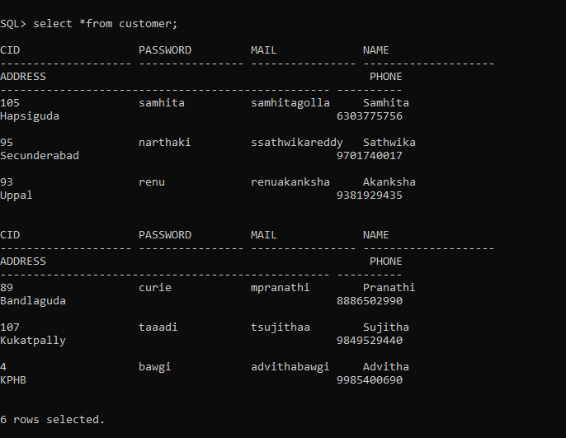

Deletion:

Proper Entry-

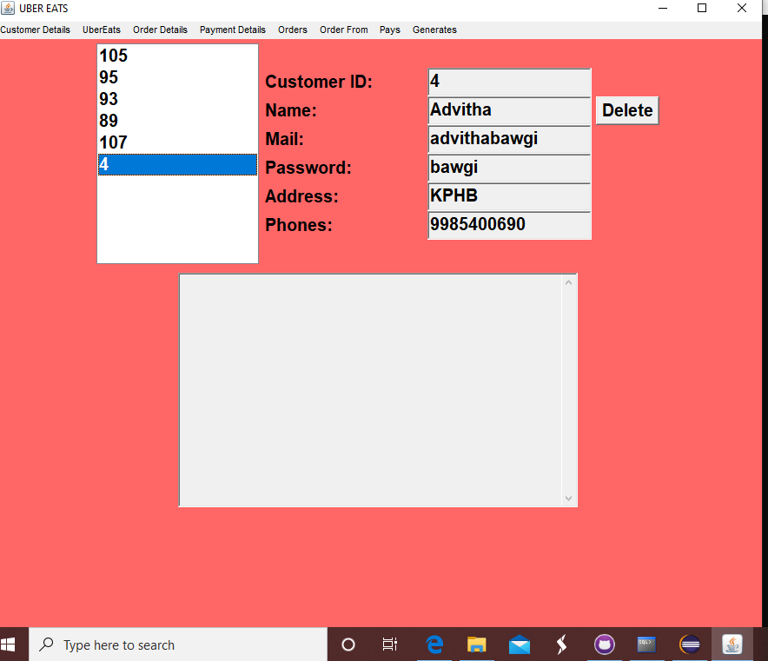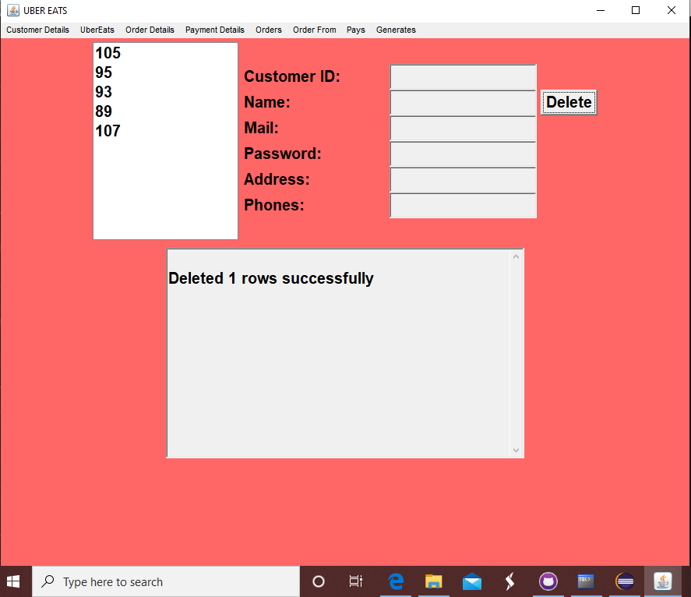

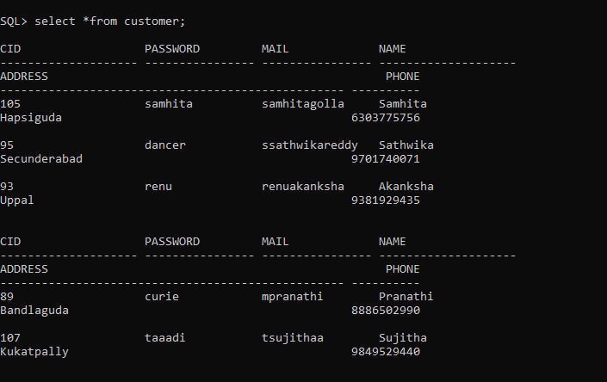

Update:

Error-

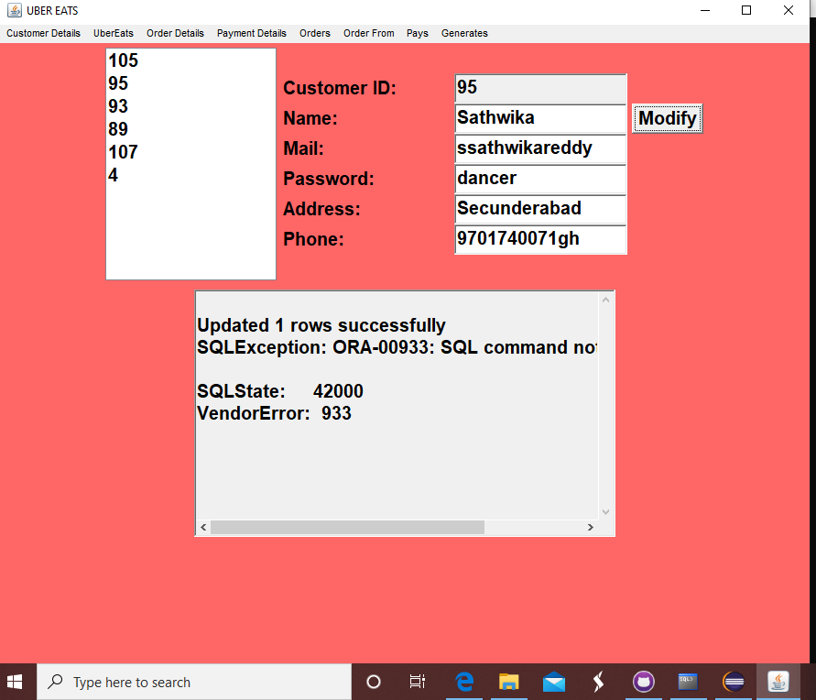

Proper Entry-

The entry of Customer Id 95 was updated from narthaki to dancer in the field of password.

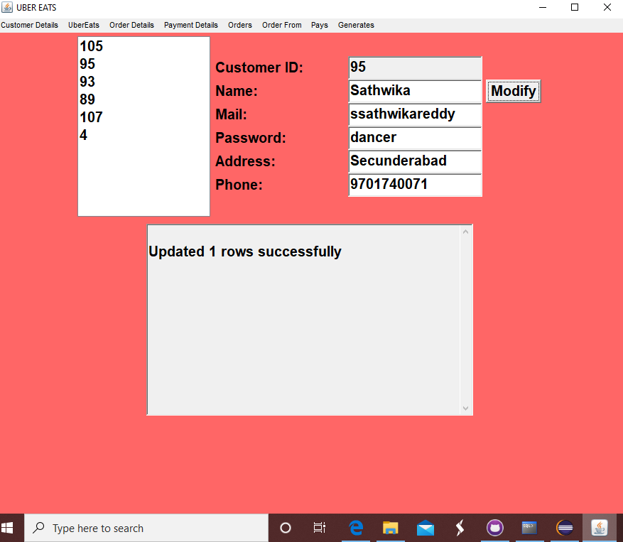



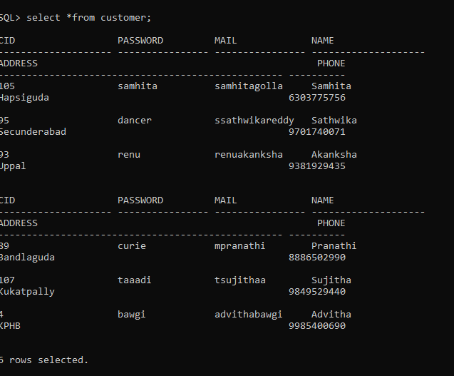

RESULTS:

The DML commands, insert, update and delete for one of the tables are given below:

For Customer table (in java as per the application):

INSERT - "INSERT INTO Customer VALUES('" + cidText.getText() + "', " + "'" + passwordText.getText() + "'," + "'" + mailText.getText() + "',"+"'"+cnameText.getText()+"'," +"'"+addressText.getText()+"',"+phoneText.getText()+")";

DELETE - "DELETE FROM Customer WHERE CID = '"+ CustomerIDList.getSelectedItem() +" ' "

UPDATE - "UPDATE Customer "+ "SET password='" + passwordText.getText() + "', "+ "mail='" + mailText.getText() + "', "+ "name ='"+ cnameText.getText()+"',"+"address ='"+ addressText.getText()+"'," +"phone=" +phoneText.getText()+ " WHERE Cid = '"+ CustomerIDList.getSelectedItem()+" ' "

1. Connection with database is established.
2. The values given for tables in the GUI components by the user are saved in the database.

REFERENCES

1. <https://en.wikipedia.org/wiki/Uber_Eats>
2. <https://eng.uber.com/uber-eats-query-understanding/>
3. <https://github.com/Samhita20/DBMS-ASSIGNMENT>